DATABASE DESIGN DOCUMENT

1. Title

Project Code :
Project Name : Infy Credit Card Inc.
System/Subsystem name :
Author : Ashwini K J
Reviewer : Ashwini K J
Date : 26-Apr-2010

2. Organization of the database

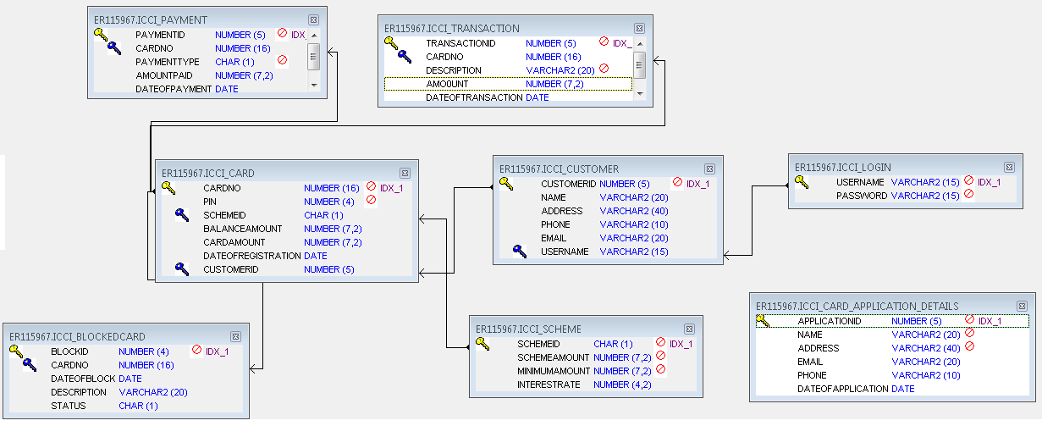

3. Tables/files or Entities

Name : ICCI_LOGIN
Synonym name : NA
Description : NA
Indexing parameters : NA
Clustering parameters : NA
Attributes/Fields : NA

No. | Field Name | Description | Size | Type | Optional/  Mandatory? | Occurs  (Instances of attribute) | Default values
1 | UserName |  | 15 | Varchar2 | Mandatory
2 | Password |  | 15 | Varchar2 | Mandatory

Volumes:
Minimum | Maximum | Average
1 | *

Volatility:
Inserts | Updates | Deletes | Reads
Y | Y | N | Y

Name : ICCI_SCHEME
Synonym name : NA
Description : NA
Indexing parameters : NA
Clustering parameters : NA
Attributes/Fields : NA

No. | Field Name | Description | Size | Type | Optional/  Mandatory? | Occurs  (Instances of attribute) | Default values
1 | SchemeId |  | 1 | Char | Mandatory
2 | SchemeAmount |  | 7,2 | Number | Mandatory
3 | MinimumAmount |  | 7,2 | Number | Mandatory
4 | InterestRate |  | 4,2 | Number | Optional

Volumes:
Minimum | Maximum | Average
1 | *

Volatility:
Inserts | Updates | Deletes | Reads
Y | Y | N | Y

Name : ICCI_CARD_APPLICATION_DETAILS
Synonym name : NA
Description : NA

Indexing parameters : NA
Clustering parameters : NA
Attributes/Fields : NA

No. | Field Name | Description | Size | Type | Optional/  Mandatory? | Occurs  (Instances of attribute) | Default values
1 | ApplicationId |  | 5 | Number | Mandatory
2 | Name |  | 20 | Varchar2 | Mandatory
3 | Address |  | 40 | Varchar2 | Mandatory
4 | Email |  | 20 | Varchar2 | Optional
5 | Phone |  | 10 | Varchar2 | Optional
6 | DateOfApplication |  |  | Date | Mandatory

Volumes:
Minimum | Maximum | Average
1 | *

Volatility:
Inserts | Updates | Deletes | Reads
Y | Y | N | Y

Name : ICCI_CUSTOMER
Synonym name : NA
Description : NA
Indexing parameters : NA
Clustering parameters : NA
Attributes/Fields : NA
No. | Field Name | Description | Size | Type | Optional/  Mandatory? | Occurs  (Instances of attribute) | Default values
1 | CustomerId |  | 5 | Number | Mandatory
2 | Name |  | 20 | Varchar2 | Optional
3 | Address |  | 40 | Varchar2 | Optional
4 | Phone |  | 10 | Varchar2 | Optional
5 | Email |  | 20 | Varchar2 | Optional
6 | UserName |  | 15 | Varchar2 | Mandatory

Volumes:
Minimum | Maximum | Average
1 | *

Volatility:
Inserts | Updates | Deletes | Reads
Y | Y | N | Y

Name : ICCI_PAYMENT
Synonym name : NA
Description : NA
Indexing parameters : NA
Clustering parameters : NA
Attributes/Fields : NA

No. | Field Name | Description | Size | Type | Optional/  Mandatory? | Occurs  (Instances of attribute) | Default values
1 | PaymentId |  | 5 | Number | Mandatory
2 | CardNo |  | 16 | Number | Mandatory
3 | PaymentType |  | 1 | Char | Optional |  | F or M or B
4 | AmountPaid |  | 7,2 | Number | Optional
5 | DateOfPayment |  |  | Date | Optional

Volumes:
Minimum | Maximum | Average
1 | *

Volatility:
Inserts | Updates | Deletes | Reads
Y | Y | N | Y

Name : ICCI_TRANSACTION
Synonym name : NA
Description : NA
Indexing parameters : NA
Clustering parameters : NA
Attributes/Fields : NA

No. | Field Name | Description | Size | Type | Optional/  Mandatory? | Occurs  (Instances of attribute) | Default values
1 | TransactionId |  | 5 | Number | Mandatory
2 | CardNo |  | 16 | Number | Mandatory
3 | Description |  | 20 | Varchar2 | Mandatory
4 | Amount |  | 7,2 | Number | Optional
5 | DateOfTransaction |  |  | Date | Optional
Volumes:
Minimum | Maximum | Average
1 | *

Volatility:
Inserts | Updates | Deletes | Reads
Y | Y | N | Y

Name : ICCI_CARD
Synonym name : NA
Description : NA
Indexing parameters : NA
Clustering parameters : NA
Attributes/Fields : NA
No. | Field Name | Description | Size | Type | Optional/  Mandatory | Occurs  (Instances of attribute) | Default values
1 | CardNo |  | 16 | Number | Mandatory
2 | Pin |  | 4 | Number | Mandatory
3 | SchemeId |  | 1 | Char | Mandatory
4 | BalanceAmount |  | 7,2 | Number | Optional
5 | CardAmount |  | 7,2 | Number | Optional
6 | DateOfRegistration |  |  | Date | Optional
7 | CustomerId |  | 5 | Number | Mandatory

Volumes:
Minimum | Maximum | Average
1 | *

Volatility:
Inserts | Updates | Deletes | Reads
Y | Y | N | Y

Name : ICCI_BLOCKEDCARD
Synonym name : NA
Description : NA
Indexing parameters : NA
Clustering parameters : NA
Attributes/Fields : NA

No. | Field Name | Description | Size | Type | Optional/  Mandatory? | Occurs  (Instances of attribute) | Default values
1 | BlockId |  | 4 | Number | Mandatory
2 | CardNo |  | 16 | Number | Mandatory
3 | DateOfBlock |  |  | Date | Optional
4 | Description |  | 20 | Varchar2 | Optional
5 | Status |  | 1 | Char | Mandatory |  | B or N
Volumes:
Minimum | Maximum | Average
1 | *

Volatility:
Inserts | Updates | Deletes | Reads
Y | Y | N | Y

STORED FUNCTIONS
Create the following stored function:
Write a stored function (sf_checkCardStatus) to check whether the entered card number is valid. If valid, check whether the card is blocked or not. The stored function should accept card number as input.
The Stored Function should return the following values under the following conditions:
1: Card number is invalid
2: Card is not blocked
<blockId>: Card is blocked
0: Exception

